**Dynamic Programming**

Optimization over plain recursion by reusing solutions of subproblems when there are overlapping subproblems.

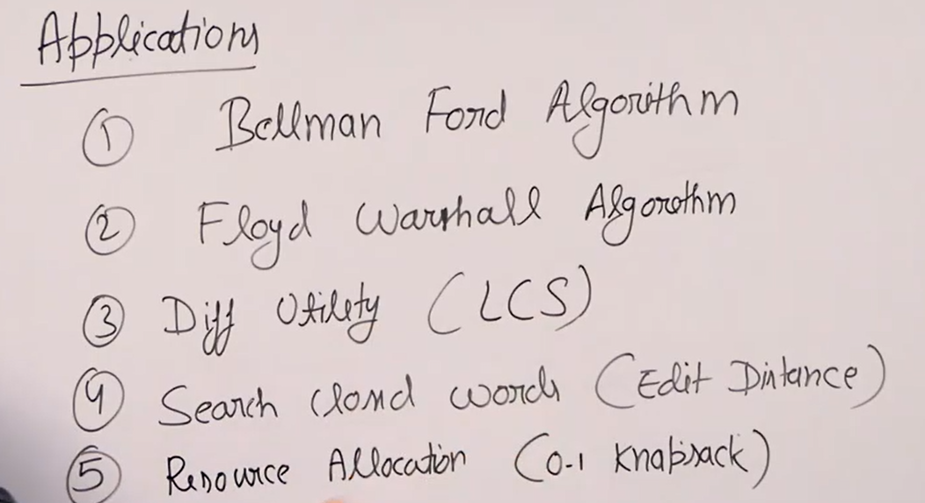

Two ways:

1. Top down (Memorization): In recursive calls, check in memo whether for that n result is already calculated, if yes return that else compute it and store in memo.
   1. No of dimensions of memo array depends upon no of input parameters to recursive function that are changing. Size of array is determined by min and max value of param.
2. Tabulation (Bottom up):

LCS Applications:

